**Z Roller Assembly**

Items needed for this step:

4 - Z_Roller.v1.1 (3D Bracket)

20 - 608 ball bearings (5 per Z Roller bracket)

16 - 5/16 1 inch or 25mm M8 bolts

4 - 5/16 1.5 inch or 40mm M8 bolts

20 - 5/16 or M8 nuts (Use thread locker or nylon nuts)

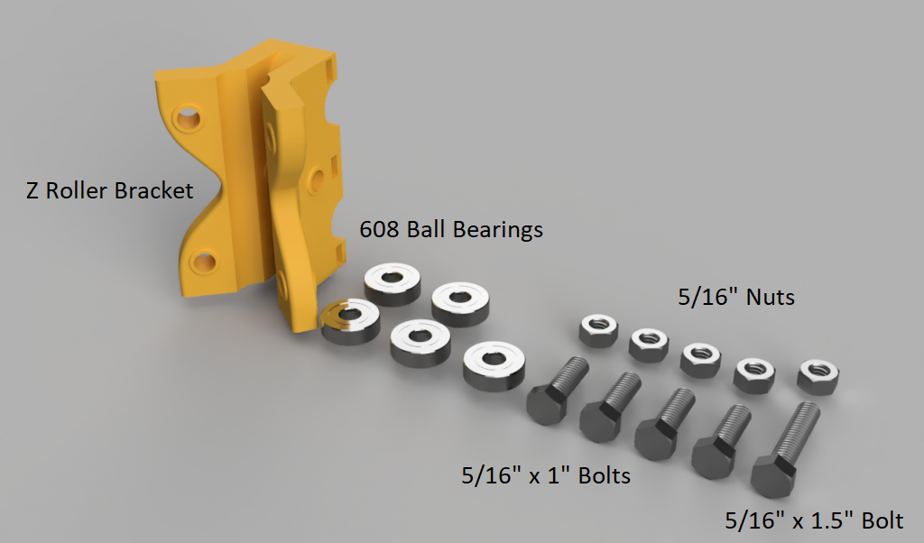

Separate the items as shown in the photo above: 1 - Z Roller, 5 – 608 ball bearings, 4 – 5/16” x 1” bolt, 1 – 5/16” x 1.5” bolt and 5 - 5/16” nuts.

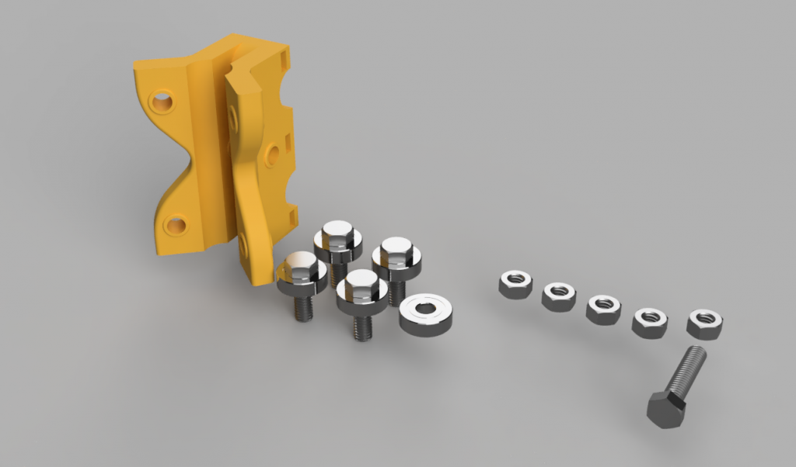

Place 1 – 608 ball bearing on each 5/16” x 1” bolt.

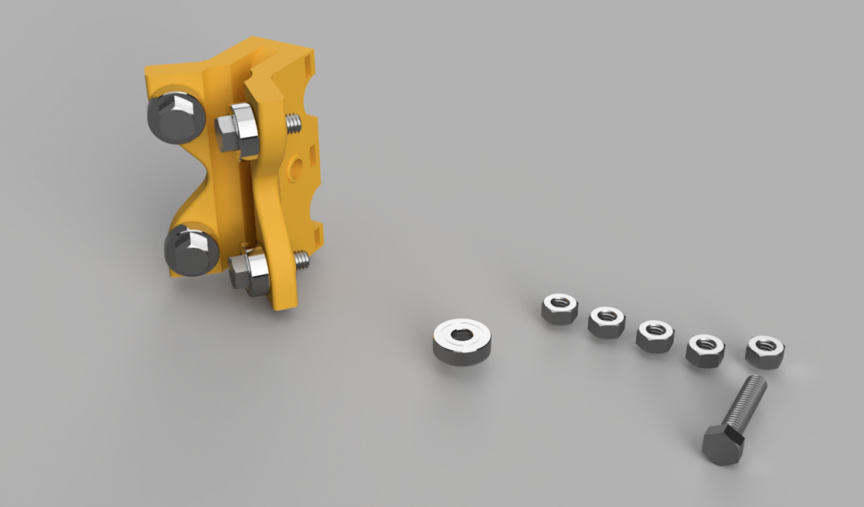

Install the 4 – 5/16”x1” bolt and 608 ball bearings in the Z Roller bracket as shown.

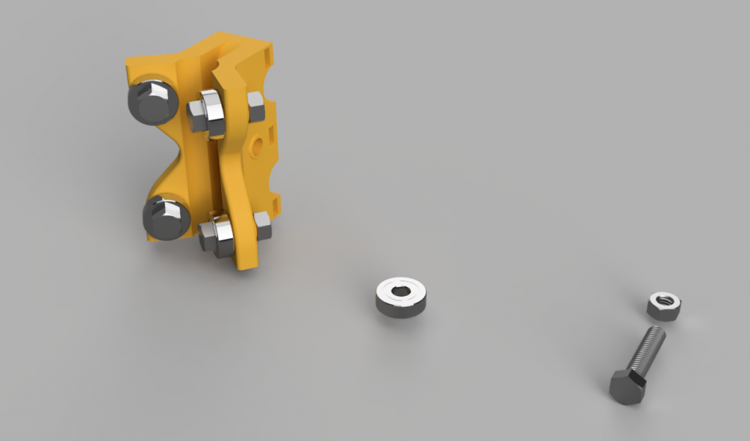

Screw 4 - 5/16” nuts on the 5/16” x1” bolt as shown. Use thread locker or nylon nuts.  
  
  
Insert 1 – 608 ball bearing inside the Z Roller Bracket (middle channel) as shown.

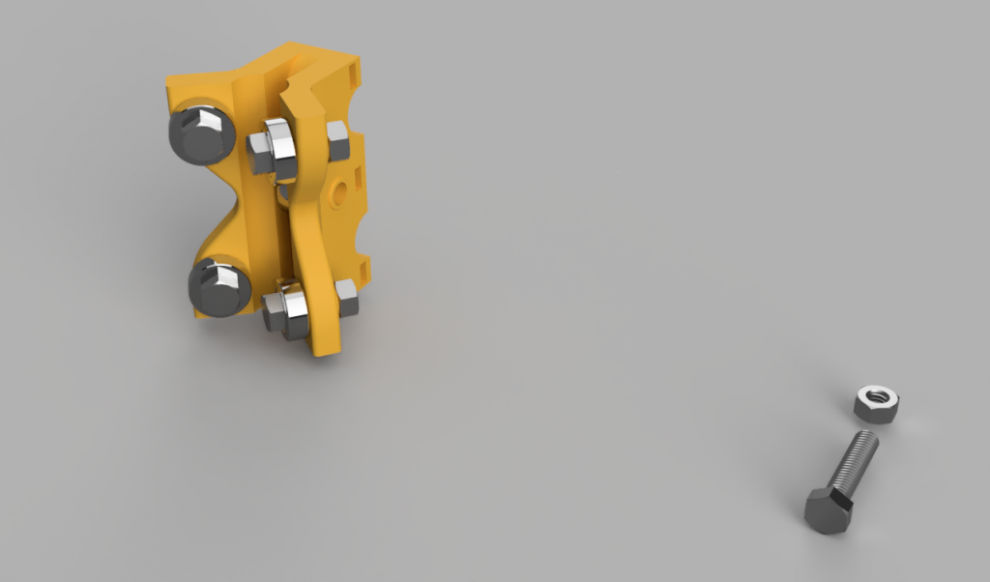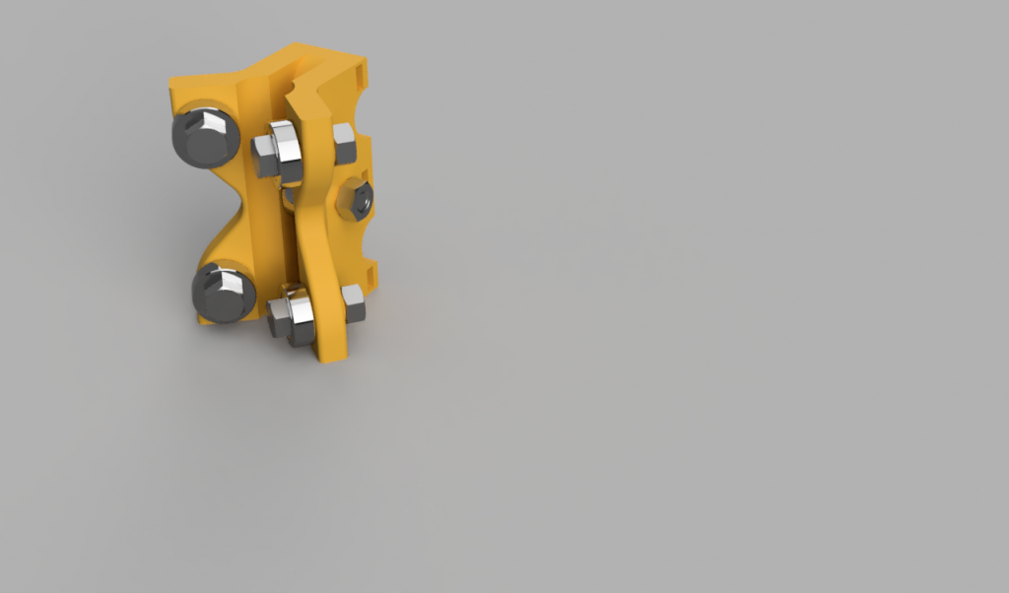

Insert the 5/16” x 1.5” bolt through the Z Roller bracket and through the 608 ball bearing. Once the bolt is inserted use the 5/16” nut on the 5/16” x 1.5 bolt as shown. Use thread locker or nylon nut.